Global Engagement Council Meeting Minutes
October 17, 2018
1:30 – 2:50 pm

Present: Bradley, Dubrule, Kim-Prieto, Olson, Quick, Rodriguez

I. Approval of October 3rd Minutes
The minutes of October 3rd were unanimously approved with no changes.

II. Discussed Global Engagement Third Party Provider Vetting Process:

CGE receives daily communications from providers and requests from TCNJ faculty and staff to consider additional affiliate providers.

A) The council evaluated a questionnaire that was developed to provide guidance on what attributes TCNJ looks for in an affiliate provider. CGE works closely with each of its affiliate providers to share information about their programs with TCNJ faculty, staff and students through our TerraDota application system. In addition, TCNJ extends invitations to our affiliate providers to participate in our annual Education Abroad Fairs.

B) The council also reviewed a rubric that aligns with the questionnaire and is intended to assist CGE, the Global Engagement Council (Part 1), and the Risk Mitigation and Crisis Management team (Part 2) in evaluating the information provided by a potential new affiliate provider.

A recommendation was made by the council on the process: Switch the order of review so that Risk Mitigation goes before Global Engagement Council on the process indicated on the rubric, motion made and carried

In addition, it was recommended that the document be reread to check for typos.

The Global Engagement Council approved the rubric itself.

The Global Engagement Council approved the process of using the rubric to assist the evaluation of third party providers.

C) Global Engagement Institute -- This is the first affiliate provider to pilot this new vetting process.

The Global Engagement Council recommended that the process and rubric be used to evaluate Global Engagement Institute (GEI) proposal in order to pilot this new process.

Meeting was adjourned at 2:50 pm.
Respectfully Submitted,
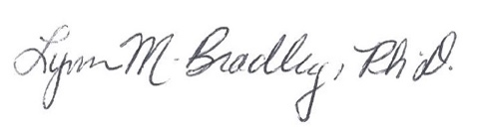
Lynn M. Bradley

