Global Engagement Council Meeting Minutes
October 3, 2018
1:30 – 2:50 pm

Present: Bradley, Cogan, Dubrule, Kim-Prieto, Olson, Quick, Rodriguez, Wei

1. Meeting minutes from September 19th approved with minor changes.

2. Request for Scheduling Proposal for 2020 --- Final Review and Approval

The committee revisited the signature line discussion (clarification requested after our last meeting). It was recommended that we continue with the optional signatures for consistency between the documents.
- Motion made to leave the signatures as presented in the document, approved unanimously by committee

3. Draft Global Engagement Vision Statement

- Review, provision of feedback

The GEC is discussing a draft vision statement for the Center of Global Engagement and the process by which to best engage the various stakeholders about the vision statement.

Meeting was adjourned at 2:50 pm.
Respectfully Submitted,
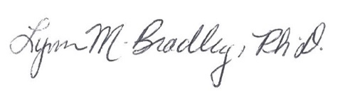
Lynn M. Bradley

