Global Engagement Council Meeting Minutes
September 5, 2018
1:30 – 2:50 pm

Present: Bradley, Cogan, Kim-Prieto, Olson, Rodriguez, Wei
Items:
- The meeting was led by Xuefeng Wei. Members introduced themselves to the group.

- Elections were held to select leadership for the committee’s 2018-2019 AY:
- Nelson Rodriguez – Chair
- Lynn Bradley – Vice-Chair

- Report from Executive Director, Christa Olson
- Global Engagement Highlights 2017-2018 (Year in Review) were presented, including summaries for global engagement review, global recruitment team, risk mitigation and crisis management and study center review
- Global Engagement Goals for the upcoming year were presented
- An agenda for the upcoming Global Engagement Workshop on Friday, September 7th was distributed

- Lee Ann Riccardi, Director for Faculty Led Programs/Risk Officer visit
- New forms for Global Experience FSP and Winter Session – we need to provide feedback ASAP
  - New program to engage freshmen in FSP and winter 1-2 week experience abroad or national; being piloted this year
  - Open to all faculty next year
  - Early deadline due to need to share with admissions for recruiting purposes
  - The language will be clarified for team teaching and faculty load in the RFP
  - Feedback needed on RFP ASAP – the document will be proofread carefully and will be submitted to the director by Friday, 9/7
- RFP for Faculty Led Programs will be discussed at our next meeting on
September 19th.
Meeting was adjourned at 2:50 pm.
Respectfully Submitted,
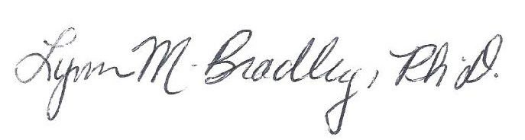
Lynn M. Bradley

