Global Engagement Council Meeting Minutes
September 19, 2018
1:30 – 2:50 pm, Bliss 114

Present: Bradley, Cogan, Dubrule, Kim-Prieto, Olson, Quick, Rodriguez
- September 5th meeting minutes were approved with minor changes.

- Faculty Led Programs

- Revisions for Review – the following documents were reviewed for approval by the GEC:

1) RFP for New Faculty Led Programs for 2020 – all indicated revisions in the document were approved by the committee with the following exceptions:
- Faculty Leaders (#4 - number of faculty leaders on page 3) – committee decided that a minimum of 2 group leaders are required for a course
- Evaluation Rubric for Faculty-Led Study Abroad Applications (end of the document)– discussed how it should be used in the decision process, committee agreed that the Final Score (max 18 pts) at the bottom of the document should be removed

- Application for New Faculty Led Programs for 2020 – all indicated revisions in the document were approved by the committee with the following exception:
-the committee agreed that under the signatures, “faculty leader 2” should be changed to “faculty leader 2 or chaperone”

- Request to Schedule Short-Term Faculty-Led Study Abroad Program - all indicated revisions in the document were approved by the committee with the following exceptions:
-the committee agreed that under the signatures, “faculty leader 2” should be changed to “faculty leader 2 or chaperone” to match the document above
-also under the signatures, it appears that the material in the ( )’s should be deleted next to Department Chair and Dean, in order to match document 2) above – we need to check for rationale behind these signatures and revisit this at our next meeting
3. Draft Global Engagement Vision Statement Discussion – postponed until our next meeting

- Global Engagement Review Working Group Charges
The group was informed that 2 working groups have been recently formed; their work will be done by June 1, 2019:
  - Global Learning Outcomes
  - Barriers for Education Abroad

Meeting was adjourned at 2:50 pm.
Respectfully Submitted,
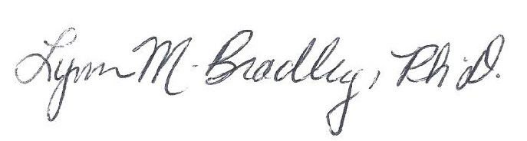
Lynn M. Bradley

